CLASS 5
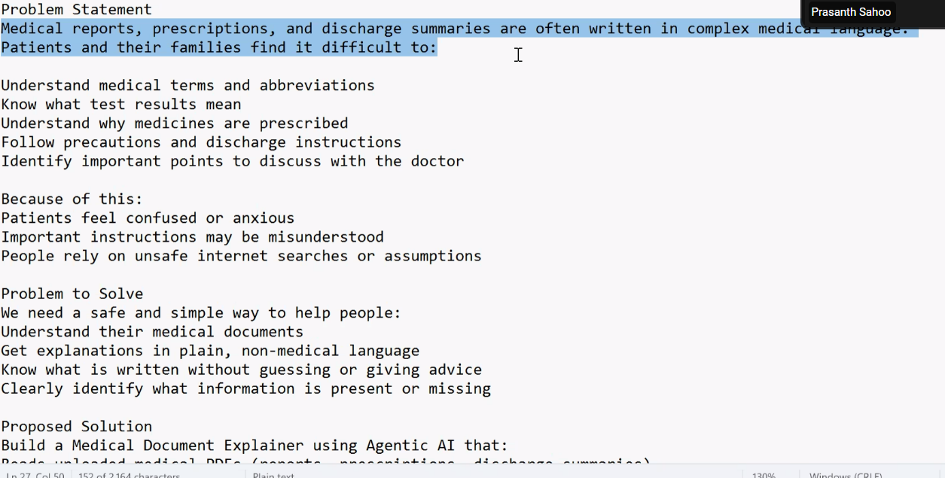

!pip install -q sentence-transformers

# ==============================
# Imports
# ==============================
import os
import gradio as gr
from google.colab import userdata

from langchain_community.document_loaders import PyPDFLoader
from langchain_text_splitters import RecursiveCharacterTextSplitter
from langchain_community.vectorstores import Chroma
from langchain_community.embeddings import HuggingFaceEmbeddings

from langchain_google_genai import ChatGoogleGenerativeAI

from langchain.agents import initialize_agent, AgentType
from langchain_core.tools import tool

# ==============================
# API Key (Gemini)
# ==============================
os.environ["GOOGLE_API_KEY"] = userdata.get("GOOGLE_API_KEY")

# ==============================
# LLM + Embeddings
# ==============================
llm = ChatGoogleGenerativeAI(
model="gemini-2.5-flash-lite",
temperature=0.2
)

embeddings = HuggingFaceEmbeddings(
model_name="sentence-transformers/all-MiniLM-L6-v2"
)

vectordb = None # global

# ==============================
# Process Medical PDFs
# ==============================
def process_pdfs(files):
global vectordb

if not files:
return "⚠️ Upload at least one medical PDF."

splitter = RecursiveCharacterTextSplitter(chunk_size=1000, chunk_overlap=200)
docs = []

for file in files:
pdf_docs = PyPDFLoader(file.name).load()
for d in pdf_docs:
d.metadata["type"] = "MEDICAL_DOC"
docs.extend(splitter.split_documents(pdf_docs))

vectordb = Chroma.from_documents(
documents=docs,
embedding=embeddings
)

return f"✅ Medical PDFs processed. Total chunks: {len(docs)}. Go to Ask tab."

# ==============================
# Tool
# ==============================
@tool
def search_docs(query: str) -> str:
"""Search medical documents and return evidence."""
global vectordb
if vectordb is None:
return "NO_DOCUMENTS: Please upload and process medical PDFs first."

results = vectordb.as_retriever(search_kwargs={"k": 6}).invoke(query)
if not results:
return "NO_MATCHES: Nothing relevant found in the documents."

return "\n\n".join(
f"{r.page_content}"
for r in results
)

# ==============================
# Agent
# ==============================
SYSTEM_RULES = """
You are a Medical Document Explainer Agent.

TASK:
- Answer questions only using uploaded medical documents
- Explain in VERY SIMPLE language
- Explain medicines, test results, and precautions
- If info is missing, say: "I don't see this information in the documents."

RULES:
- Use search_docs BEFORE answering
- Do NOT give medical advice
- Always end with:
"This is NOT a substitute for a doctor's advice. Please consult a doctor."
"""

agent = initialize_agent(
tools=[search_docs],
llm=llm,
agent=AgentType.ZERO_SHOT_REACT_DESCRIPTION,
verbose=False
)

# ==============================
# Chat
# ==============================
def medical_chat(message, history):
return agent.run(f"{SYSTEM_RULES}\n\nUser question: {message}")

# ==============================
# UI
# ==============================
with gr.Blocks() as demo:
gr.Markdown("# 🩺 Medical Document Explainer")

with gr.Tab("Upload"):
files = gr.File(
label="Upload Medical PDFs",
file_types=[".pdf"],
file_count="multiple"
)
b = gr.Button("Process", variant="primary")
s = gr.Textbox(label="Status", lines=4, interactive=False)
b.click(process_pdfs, files, s)

with gr.Tab("Ask"):
gr.ChatInterface(
fn=medical_chat,
examples=[
"What does this medicine do?",
"What precautions should I take?",
"Explain the blood test results in simple words.",
"Summarize the discharge advice."
]
)

demo.launch(share=True)

